NAME: __________________________ DATE DUE: ____________
TEACHER: ________________________
/33
Year 11 Term 1 – Chemistry
HOMEWORK SHEET No. 5 – Gases

/5 | 1. List the key points of the Kinetic Molecular Theory (KMT) of gases. NOTE: Your answer should be succinct and focus on the key point, not be repeated verbatim from notes.
/4 | 2. Use your knowledge of the KMT to explain the following scenario. “An inflated balloon, left in a locked car on a hot day, will expand and possibly explode.”  Scaffold – firstly identify the relevant key points of the KMT. Secondly use these points to explain how an increase in temp causes the volume of the balloon to increase.
/1 | 3. Write two mathematical formulas which describes the idea gas law.
/1 | 4. What is the value of, and what are the units for, the universal gas constant, R
/3 | 5. Convert the following values to the units indicated in the brackets  a) 1023 mmHg (to kPa) d) 0.36 cm³ (to L)  b) 450 ⁰C (to K) e) 32 m³ (to L)  c) 0.05 atm (to kpa) f) 0.013 mL (to L)
/2 | 6. The Gas in a balloon occupies 3.3 L. What volume will it occupy if the pressure is changed from 100 kPa to 90 kPa at a constant temperature of 310 K.
/2 | 7. A 7.50 litre sealed jar at 18 °C contains 0.125 moles of oxygen and 0.125 moles of nitrogen gas. What is the pressure in the container?
/2 | 8. A 500 mL metal cylinder holding 0.5 grams of helium gas is known to rupture at a pressure of 10 atmospheres. At what temperature, in °C, will the container fail?
/3 | 9. A 60.0 L tank of chlorine gas at 27 °C and 125 atm springs a leak. When the leak was discovered, the pressure was reduced to 50 atm although the temperature had not changed. How many moles of chlorine gas escaped?
/3 | 10. If you burned 100 grams of octane (petrol) (C₈H₁₈), how many litres of carbon dioxide would be produced at a temperature of 350.0°C and a pressure of 1.00 atm? (hint: equation is not balanced)  C₈H_{18(l)} + O_{2(g)} → CO_{2(g)} + H₂O_{(g)}
/4 | 11. (a) On the following graph sketch the line you would expect an ideal gas to conform to.  (b) Explain your reasoning  Temperature (K)  $$\frac{PV}{n}$$  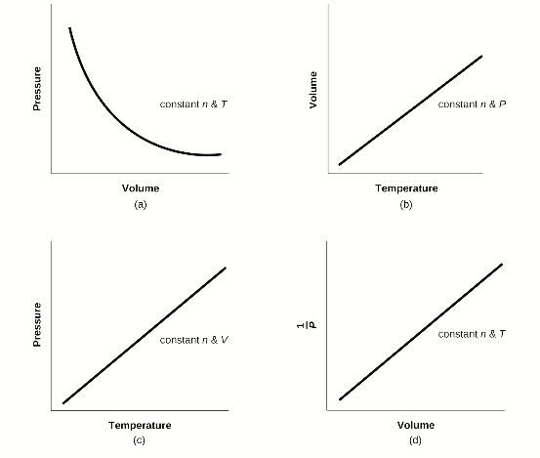  c) identify which of the graphs on the right are consistent with the mathematical relationships in the ideal gas law.

